An introduction to single best answer (SBA) questions

Here is an example showing how an SBA question might appear in an exam:

Toenail problem
A 53-year-old man has discoloured toenails which are causing discomfort.
A photo of his nails is shown:
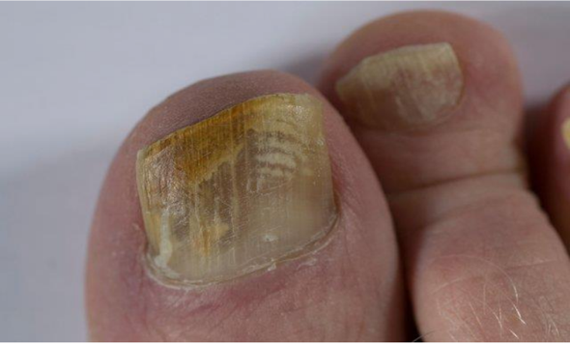
Which is the most appropriate investigation? Select one option only.

A. Skin scrapings
B. Liver function tests
C. Full blood count
D. Nail clippings
E. HbA_{1c}

This document will look at the structure of SBA questions:

1. Title

Toenail problem

A 53-year-old man has discoloured toenails which are causing discomfort.
A photo of his nails is shown:

2. Scenario

3. Additional information, (if any)

Which is the most appropriate investigation? Select one option only.

4. Lead-in

A. Skin scrapings
B. Liver function tests
C. Full blood count

5. Answer options
D. Nail clippings
E. HbA_{1c}
SBAs usually have a standard structure:
- Title

Toenail problem

- A short heading for context
- Intended to help focus on a different GP Curriculum topic area compared to a previous question
Top Tip:
- Remember to read the title

- Scenario

A 53-year-old man has discoloured toenails which are causing discomfort.
A photo of his nails is shown:

- Most questions summarise a short, clinical, primary care presentation
- Typically starting with a person’s age and gender
- Followed by a chronological summary of relevant information, which may include:
  - new and chronic symptoms
  - past medical history
  - medication
  - allergies
  - focussed examination (whether normal or abnormal)
  - test results
- Most scenarios have between one and five lines of text
- A limited number of factual questions will have no clinical scenario
Top Tips:
- Identify key Information from the scenario by slowing down, and re-reading carefully
- The information given is relevant to answering the question, for example, the given age or duration of symptoms
- Additional information

3. Additional information, (if any)

- Questions may include information in addition to a scenario, such as:
  - clinical images including ECGs
  - test results in table format
  - graph
  - chart
  - other data
- Most questions with additional information to interpret will have shorter scenarios, or sometimes no scenario at all
- Images
  - Photographs may show normal or abnormal findings
  - Use information from the scenario and your interpretation of the photo to answer the question
  - The question may be about diagnosis, investigation, or management
- Test results
  - Look for abnormal values and patterns
  - Normal ranges will be given, except for some common values which need tailoring to individual patient circumstances, for example, HbA_{1c} and lipid profiles
- Tables
  - Look for abnormal values and patterns
- ECGs
  - Look for normality and abnormalities.
  - Link your findings to information within the scenario
Top Tips:
Some questions have a ‘two-step’ process. In the example question from page one:
- It is necessary to first make a diagnosis from the given scenario and image
- Before subsequently then being able to best answer the lead-in question, ‘Which is the most appropriate investigation?’
- Lead-in

Which is the most appropriate investigation? Select one option only.

4. Lead-in

- It defines the exact question being asked
- May begin ‘According to national guidance’ or ‘According to the current BNF’
- A small number explicitly ask for multiple (usually two) correct answers
- Some words are in bold for emphasis to meaning, for example:
  - "…the most likely diagnosis"
Choose the most plausible diagnosis based on the scenario. Although other answers may form part of a reasonable differential diagnosis, one answer will best match the scenario
  - "…the most appropriate next management"
This is emphasising the need to look for what should be done now be done. It is not asking about other possible future treatments
  - "…the most appropriate initial management"
Which action is essential to take first in primary care, before considering other relevant choices?
  - "…the most appropriate initial investigation"
Which test is important to do first in primary care to confirm or rule out a significant diagnosis? Look for a single test, the outcome of which will guide subsequent decision-making

Top Tips:
- Some candidates find it helpful to read the lead-in question first before looking at the scenario. This may help focus on what is being asked
- Remember that the answer must be based on national not local guidance

- Answer options

A. Skin scrapings
B. Liver function tests
C. Full blood count

5. Answer options
D. Nail clippings
E. HbA_{1c}

- Most commonly SBAs are ‘best of five’ answer options, but occasionally more or less
- Answer options will be in a randomised order
- Answers will match guidance across England, Northern Ireland, Scotland and Wales.

Top Tips:
- Some candidates find the ‘cover test’ helpful. This involves trying to work out the answer before looking at the options. If the answer you come up with is one of the five listed answers, then it is likely correct
- Exclude clearly incorrect answers
- Frequently a question will be asking for the most ‘likely’ diagnosis, which is not necessarily the most ‘serious’ diagnosis
- Remember that ‘no action’ or the recognition of normality may sometimes be the correct answer

Please refer to the many other exam preparation resources on the AKT website.
Any queries about this document please email exams@rcgp.org.uk

